Email 4a: General Thank You #1
From:
Audience: All company employees
Call to Action: See your impact

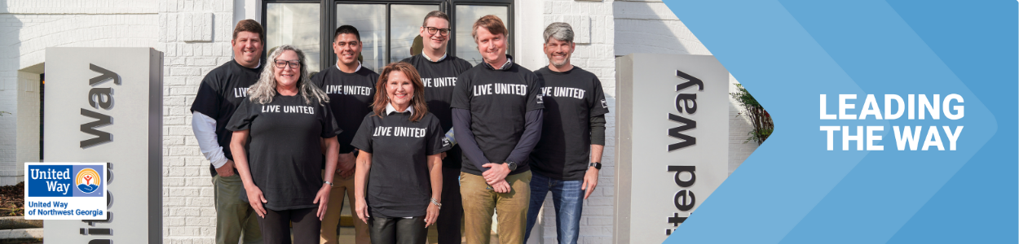
Subject Line: Thank you for Leading the Way in Whitfield and Murray counties
Preheader Text: [intentionally left blank]
Email Body:

Dear [Name],

Join me in celebrating the success of [Company Name’s] efforts to Lead the Way by changing lives in our community.

I’m thrilled to report: [customize]

[Company Name] employees gave $ [dollars pledged] to United Way of Northwest Georgia
[participation rate%] of [Company Name] Employees gave to United Way of Northwest Georgia
[number of donors] of [Company Name] employees gave to United Way of Northwest Georgia
[Company Name] employees contributed more than [number of volunteer hours] volunteer hours during the campaign.

Together, our collective impact is creating a better future for youth, families and communities in Whitfield and Murray counties. Thank you for Leading the Way!
BUTTON TEXT: SEE YOUR IMPACT [Hyperlink]
[Closing],
Your United Way CEO/CPO, Board or Campaign Chair’s first and last name

