Email 4a: Donor Thank You #2
From: Your United Way CEO/CPO, Board or Campaign Chair’s first and last name
Audience: Company employees who donated to United Way (not designated to other organizations)
Call to Action: Continue your support
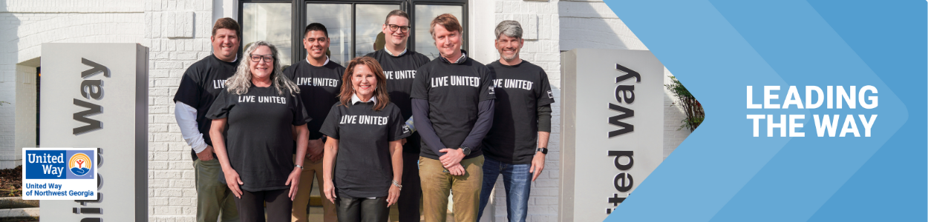
Subject Line: Thank you for Leading the Way in Whitfield and Murray counties
Preheader Text: [intentionally left blank]
Email Body:
Dear [Name],
First, thank you for Leading the Way in our community through your generous gift to United Way of Northwest Georgia. Your donation is making a real difference in the lives of our neighbors and friends.
Today and every day, we need you with us. Here are ways that your support can continue making our community a better place:
  - Volunteer: Make a difference by volunteering – providing a meal to someone who’s homebound, reading to preschoolers to get them school-ready, or passing out food to neighbors in need. Consider serving on United Way’s Community Solutions Allocation Panels or offering your unique skills to a local nonprofit who needs your expertise.
  - Advocate: Encourage your neighbors and colleagues to become active in our community and raise your voice on the issues that impact hard-working families in our community. Join United Way of Northwest Georgia’s events to help every person thrive.
  - Stay in the Loop: Signup for our email newsletter to keep informed about what’s going on at United Way!
Thank you for your commitment to bettering our community. Together, let’s Lead the Way to a better future for all. United, We Do More!
[Closing],
Your United Way CEO/CPO, Board or Campaign Chair’s first and last name
BUTTON TEXT: Join us! [Link to newsletter - https://www.ourunitedway.org/newsletter-signup]

