Email 3b: Reminder #2
From: Your United Way CEO/CPO, Board or Campaign Chair’s first and last name
Audience: All company employees
Call to Action: Join the campaign by donating
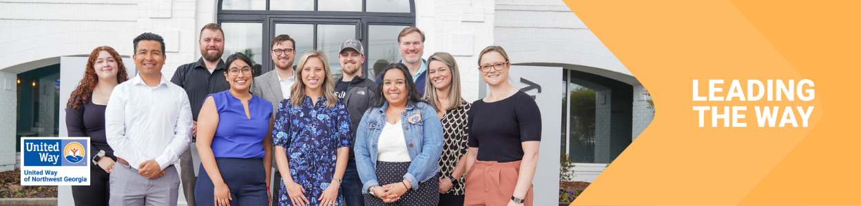
Subject Line: How United Way and [Company Name] are Leading the Way
Preheader Text: Partnered up to create real impact
Email Body:

Dear [Name],
We want to take a moment to celebrate how United Way of Northwest Georgia and [Company Name] are partnering to change lives in our community.

Thanks to [Company Name]’s support and people like you…
[This email should be tailored to your relationship with the company. We suggest:
Highlight the number of years a company has been a sponsor
Highlight the impact the company has had during make a difference day or volunteer projects—the # of hours, the value of that volunteer service to the community. How United Way has helped deepen the company culture around service. Add photos from said events.
Has the company done food drives or holiday drives through united way to benefit the community?
Does the company have a number of hours of volunteerism to celebrate?]
Let’s build on [Company Name]’s legacy to do even more. Donate today to Lead the Way to a better future for Whitfield and Murray counties.

BUTTON TEXT: Donate [Hyperlink]
[Closing],
Your United Way CEO/CPO, Board or Campaign Chair’s first and last name

