Email 3a: Reminder #1
From: Your United Way CEO/CPO, Board or Campaign Chair’s first and last name
Audience: All company employees
Call to Action: Join the campaign by donating
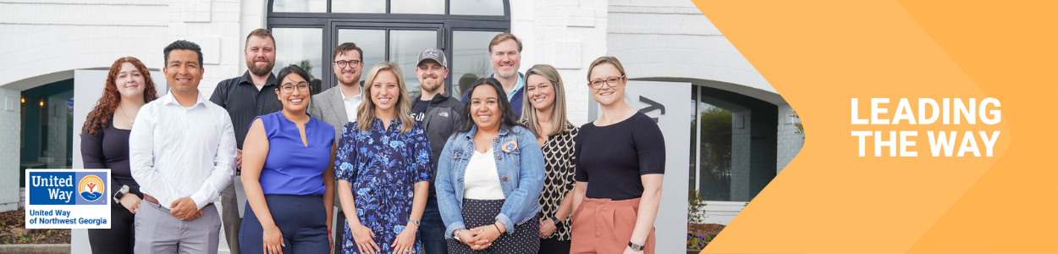
Subject Line: What are we doing together in Whitfield and Murray counties?
Preheader Text: Mobilizing our community and changing lives.

Email Body:

Hi [Name],
We need you with us-- whether you’re new to United Way of Northwest Georgia or you’ve been creating impact with us for years.
At United Way, we believe that everyone who lives and works in Whitfield and Murray counties deserves the opportunity to thrive. Together with you and partners like [Company Name], United Way mobilizes the caring power of people to create transformational change in our local community.
Day in and day out, United Way of Northwest Georgia supports and develops programs that meet the most urgent needs in our community. We’re proud of all we’ve accomplished together for our great community:
- 29,844 bed nights provided to people in need of shelter from a domestic violence situation
- 18,565 individuals provided with food assistance
- 5,942 youth received help to graduate high school on time with skills to be life-ready
- 8,751 children learned to recognize or prevent abuse
More work is needed to build on this momentum. If you’ve already given, thank you. If you haven’t, there’s still time to join in.
BUTTON TEXT: Donate [Hyperlink]
Together, let’s Lead the Way and make great things for people who call [Anytown] home.
[Closing],
Your United Way CEO/CPO, Board or Campaign Chair’s first and last name

