Email 2:
From: Your United Way CEO/CPO, Board or Campaign Chair’s first and last name
Audience: All company employees
Call to Action: There’s still time to give now and join the campaign
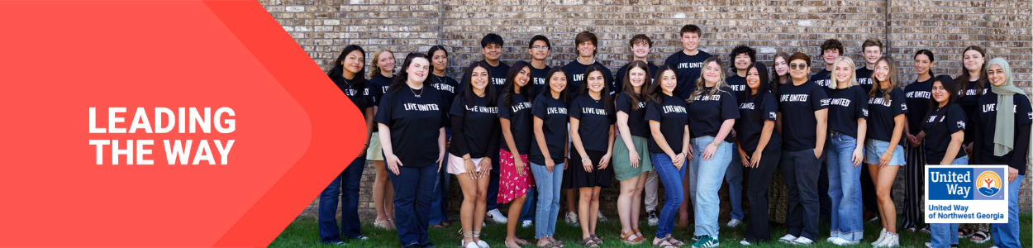
Subject Line: Lead the Way in Whitfield and Murray counties
Preheader Text: What makes United Way of Northwest Georgia so special?

Email Body:

Dear [First name],
United Way of Northwest Georgia mobilizes communities to action so that all can thrive. Whenever there’s a need in our community, United Way is there. [Anytown] is all about creating a future where everyone, everywhere can rise. And thanks to people like you, we positively impacted almost 65,000 people last year alone.
And we’re not stopping there. Your support can help continue tackling the biggest problems in [Location]. From education and health to hunger and natural disasters, we bring a comprehensive approach to every challenge. Because more than [number] years of experience has shown us that when people unite to take action, change is possible.
Donate today. Join us in Leading the Way to a better future for all.
BUTTON TEXT: LEAD THE WAY [Hyperlink]
[Closing],
Your United Way CEO/CPO, Board or Campaign Chair’s first and last name

