Email 1b: Company CEO variation
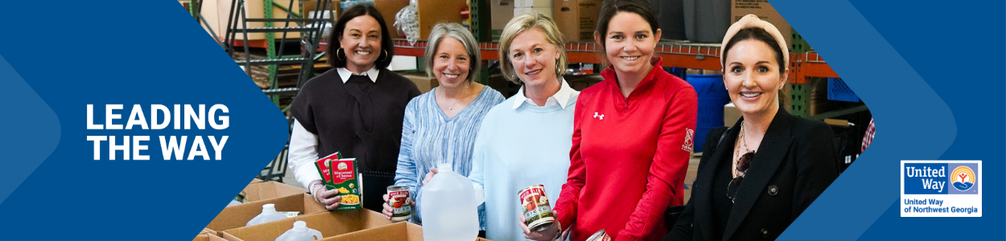
Subject Line: [Company Name] is Leading the Way in [Anytown]
Preheader Text: In our community, everyone deserves the opportunity to thrive.
Email Body:
[Name],
United Way of Northwest Georgia supports the needs of our community every day to help strengthen our community to ensure everyone will thrive. Join me in leading the way for our community by participating in this year’s campaign. We’ve set an ambitious goal of raising [monetary goal/description] to help do just that.
I believe that when we come together as a team, there’s no challenge that can’t be solved. That’s why I’m inviting you to join me in Leading the Way toward positive change in Whitfield and Murray counties. This is more than a campaign – it is a call to action for us at [Company Name] to advance solutions to real problems facing people in the communities where we live and work.
Together, we can advance health, youth opportunity, financial security and strengthen overall community resilience to build a future where everyone can reach their full potential. We’re counting on generous people like you and your teammates to help improve the lives of people in our community. Last year, United Way of Northwest Georgia was able to provide 20,098 individuals with food, clothing, furniture, prescription medication, and/or rent/utility assistance, deliver 75,505 meals to home-bound elderly, and almost 65,000 LIVES were CHANGED in Whitfield and Murray counties with our support. And this year, with your help, we know that we can do even more.
[Insert information about how they can donate]
BUTTON TEXT: LEAD THE WAY [Hyperlink]
I want to thank you in advance for your valuable support and for Leading the Way here at [Company Name].
[Closing],
Company CEO, Leader, or Employee Campaign Chair’s first and last name

