Email 1a: Campaign Welcome and Kick-Off

From: Your United Way CEO/CPO, Board or Campaign Chair’s first and last name
Audience: All company employees
Call to Action: Give now to join the campaign
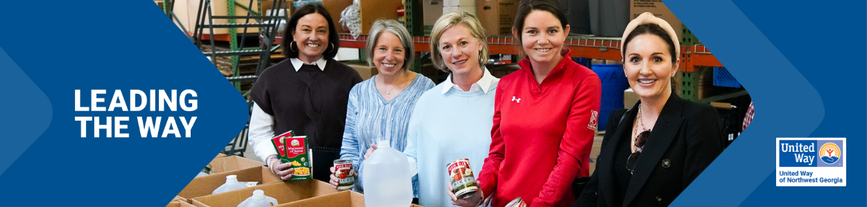
Subject Line: Leading the Way in Whitfield and Murray counties
Preheader Text: In our community, everyone deserves the opportunity to thrive.
Email Body:
[Name],
Join [Company Name] in leading the way for a better future for all by donating today.
Your support of United Way of Northwest Georgia will allow us to advance health, youth opportunity, financial security to ensure our neighbors can thrive. Our work is powered by generous supporters, like you and [Company Name], who are committed to #LeadingTheWay to a stronger community.
Because of your generous support, United Way of Northwest Georgia is making a difference in the lives of almost 65,000 people every year. We need you with us. Donate today and join us in Leading the Way to a better future for all.
LEAD THE WAY [Hyperlink]
Closing,
Signature

